Project Demonstration Phase
Dashboards and Story screenshots with Tableau public, Dataset, Source code & Project demo links Template

Date | 03 July 2026
Team ID
Project Name | Heritage Treasures: An In-Depth Analysis of UNESCO World Heritage Sites in Tableau
Maximum Marks

Dashboards:

1. UNESCO World Heritage Sites Overview
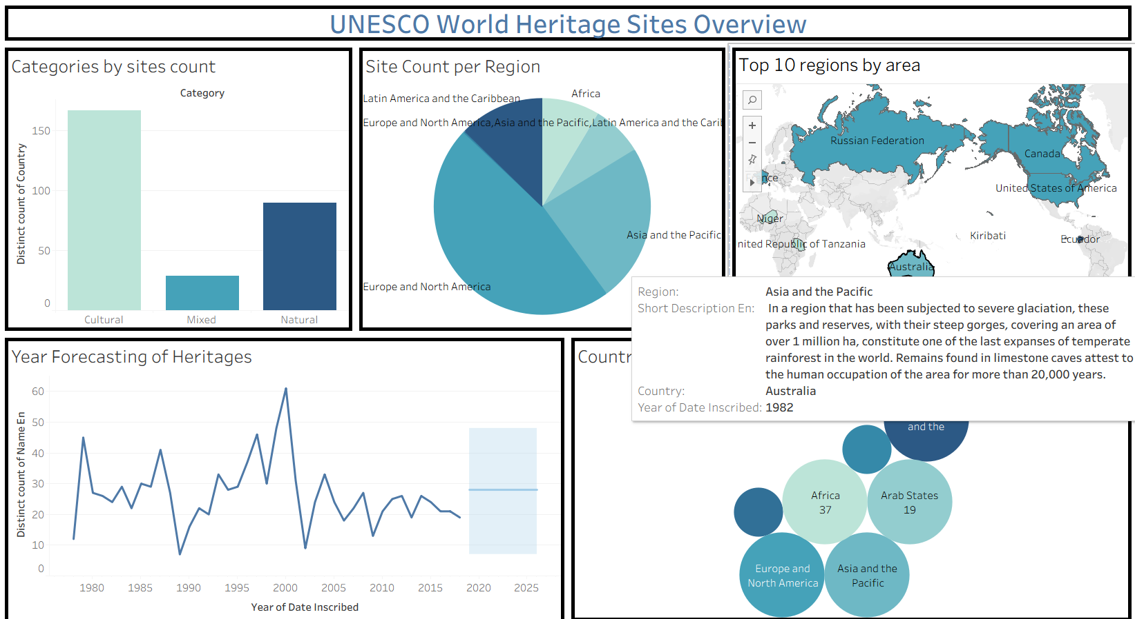
The UNESCO World Heritage Sites Overview Dashboard provides an interactive overview of UNESCO heritage sites across the world. It presents key insights such as regional distribution, heritage categories, endangered sites, and historical trends through various visualizations. The dashboard enables users to analyse and compare heritage data efficiently, supporting better understanding of global heritage conservation and decision-making.

2. UNESCO Danger Sites Overview
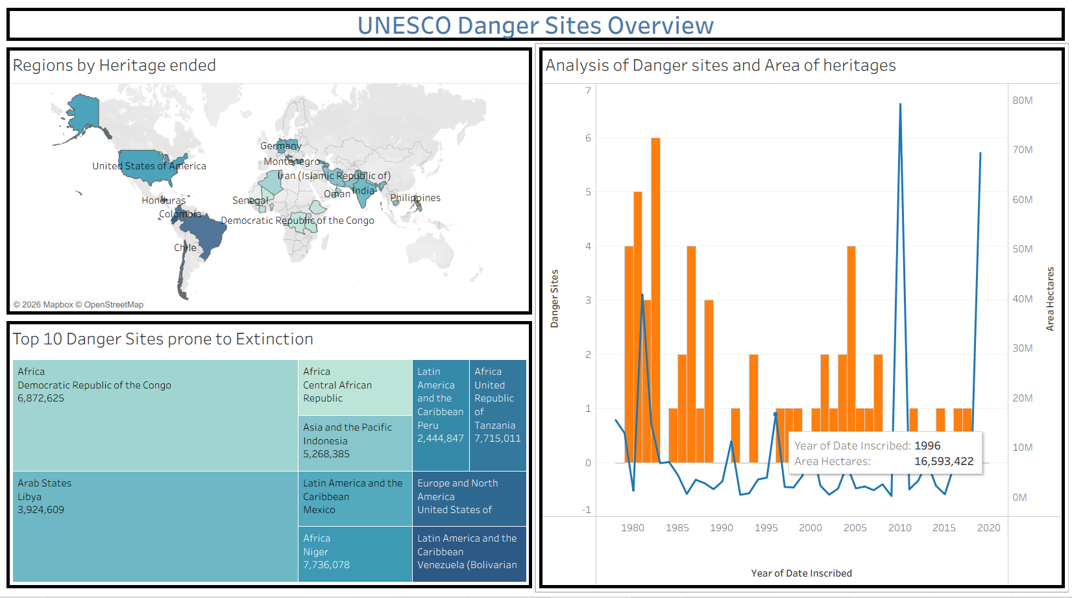
The UNESCO Danger Sites Overview Dashboard provides an interactive analysis of UNESCO World Heritage Sites that are classified as endangered. It highlights the distribution of danger sites across different regions, identifies sites at risk of extinction, and presents conservation-related insights through interactive visualizations. The dashboard helps users understand endangered heritage patterns and supports awareness of global heritage preservation efforts.

Story Points:
1. UNESCO World Heritage Sites:
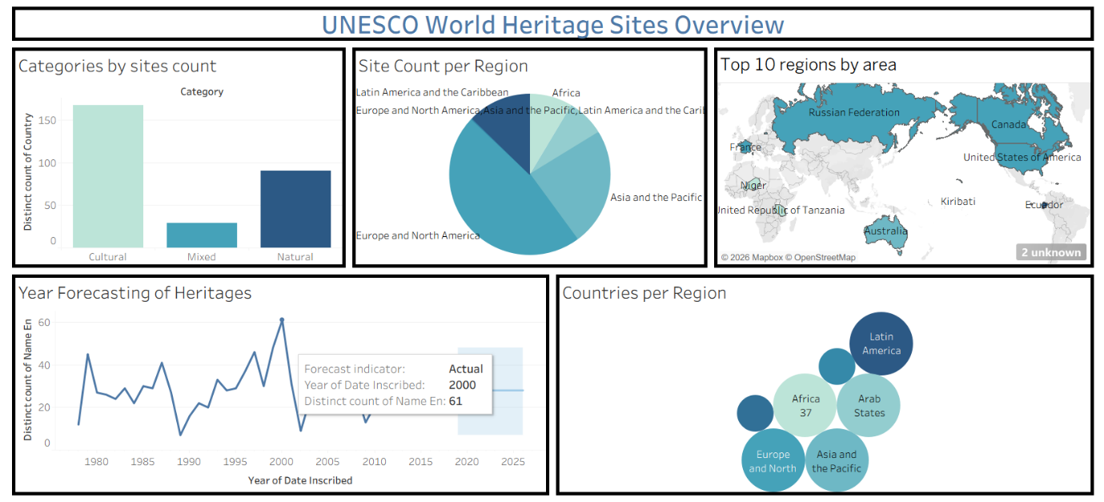
The UNESCO World Heritage Sites Overview Story presents a sequential analysis of UNESCO World Heritage Sites through interactive story points. It combines multiple visualizations to showcase regional distribution, heritage categories, endangered sites, forecasting trends, and key insights. The story enables users to explore the data step by step, providing a clear understanding of global heritage patterns and conservation efforts.

2. Regional Distribution of Heritage Sites
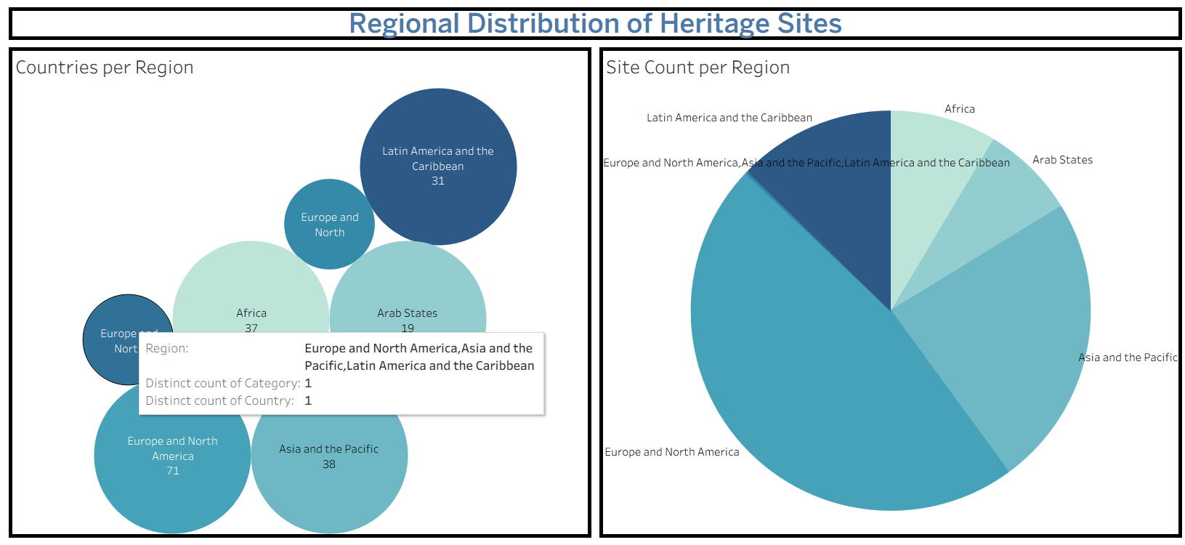
The Regional Distribution of Heritage Sites Story provides an interactive analysis of how UNESCO World Heritage Sites are distributed across different regions of the world. It highlights regional variations, compares the number of heritage sites, and presents key insights through sequential visualizations. The story helps users understand global heritage distribution patterns and supports effective analysis of regional heritage representation.

3. Analysis of Heritage Sites at Risk
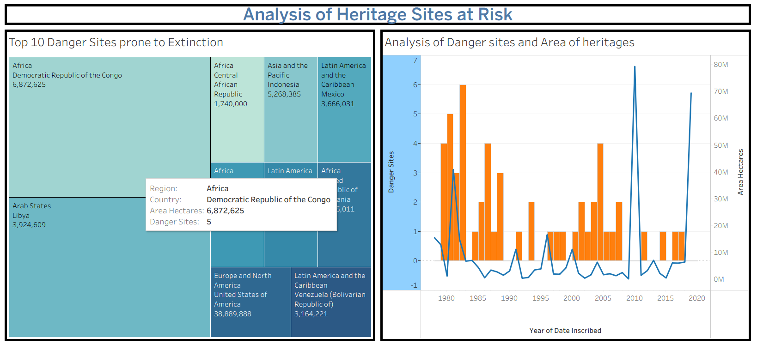
The Analysis of Heritage Sites at Risk Story provides an interactive overview of UNESCO World Heritage Sites that are threatened by various environmental and human-induced factors. It highlights endangered sites across different regions, compares their distribution, and presents key conservation insights through interactive visualizations. The story helps users understand the importance of protecting vulnerable heritage sites and supports global heritage conservation efforts.

4. Heritage Area and Inscription Trend Analysis
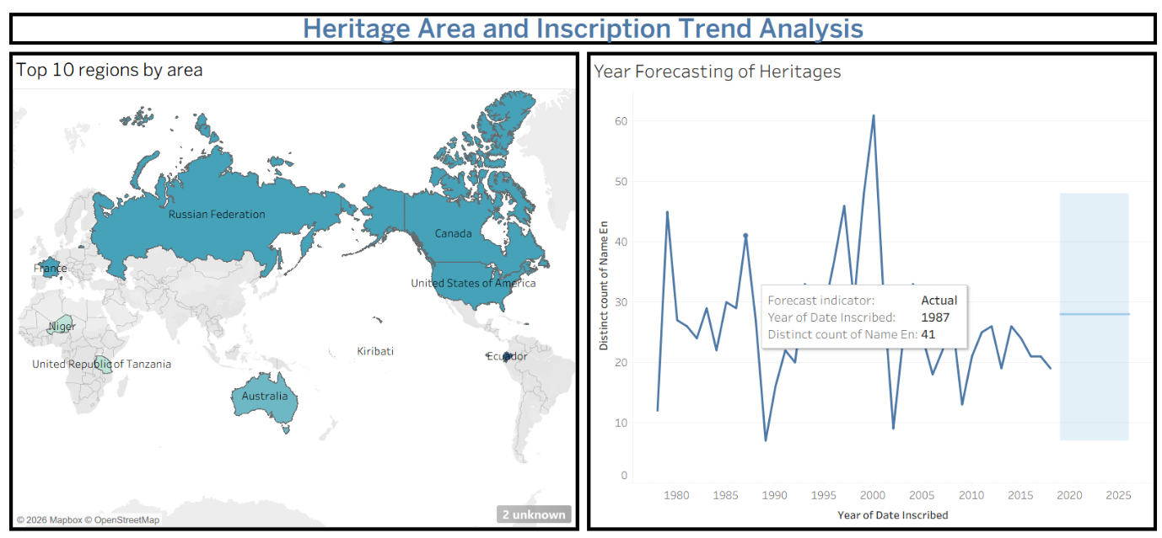
The Heritage Area and Inscription Trend Analysis Story provide an interactive analysis of UNESCO World Heritage Sites by examining their geographical area and historical inscription trends. It presents insights into heritage site growth over the years, compares site areas across regions, and highlights significant patterns through interactive visualizations. The story helps users understand the evolution of UNESCO heritage sites and supports informed heritage conservation planning.

5. Heritage Site Categories and Regional Comparison
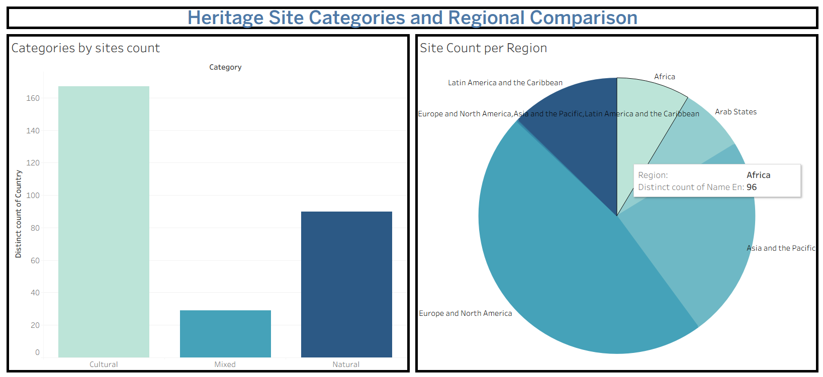
The Heritage Site Categories and Regional Comparison Story provide an interactive comparison of UNESCO World Heritage Sites across different heritage categories and world regions. It highlights the distribution of cultural, natural, and mixed heritage sites while comparing regional contributions through interactive visualizations. The story helps users understand category-wise heritage patterns and regional diversity, supporting a comprehensive analysis of global UNESCO heritage sites.

Tableau Public Links:
Dashboard 1 Public Link:
https://public.tableau.com/views/Book_Main_17829132597600/Dashboard1?:language=en-US&publish=yes&:sid=&:redirect=auth&:display_count=n&:origin=viz_share_link

Dashboard 2 Public Link:
https://public.tableau.com/views/Book_Main_17829132597600/Dashboard2?:language=en-US&publish=yes&:sid=&:redirect=auth&:display_count=n&:origin=viz_share_link

Story Public Link:
https://public.tableau.com/views/UNESCOHeritage_17829137760690/Story1?:language=en-US&publish=yes&:sid=&:redirect=auth&:display_count=n&:origin=viz_share_link

Dataset Link:
https://www.kaggle.com/datasets/ujwalkandi/unesco-world-heritage-sites/data?select=whc-sites-2019.csv

Source Code Link:
https://drive.google.com/drive/folders/1SXpnThdWDYB22FdTqFe0X6L3ZZUrX5ed?usp=sharing

Project Demo Link:
https://drive.google.com/file/d/1pUAOwX2ZQNVfUqhDaOMuID2mP8tLvn5-/view?usp=sharing

